**HOME STAY RESERVATION SYSTEM**

MISHAL SHAKINA RAJAMANICKAM

Academic project I report submitted in FULFILMENT OF the requirEmentS FOR the **Executive Diploma in Information Technology**

**CEntre for continuing education (UMCCed)**

UNIVERSITY OF MALAYA

Kuala lumpur

**2022**

**UNIVERSITY OF MALAYA**

**ORIGINAL LITERARY WORK DECLARATION**

Name of Candidate: Mishal Shakina (I.C/Passport No: (950620-14-8102)

Matric No: UFH190045

Name of Degree: The Executive Diploma in Information Technology

Title of Project Paper/Research Report/Dissertation/Thesis (“this Work”):

Home Stay Reservation System

Field of Study: Information Technology

I do solemnly and sincerely declare that:

1. I am the sole author/writer of this Work;
2. This Work is original;
3. Any use of any work in which copyright exists was done by way of fair dealing and for permitted purposes and any excerpt or extract from, or reference to or reproduction of any copyright work has been disclosed expressly and sufficiently and the title of the Work and its authorship have been acknowledged in this Work;
4. I do not have any actual knowledge nor do I ought reasonably to know that the making of this work constitutes an infringement of any copyright work;
5. I hereby assign all and every right in the copyright to this Work to the University of Malaya (“UM”), who henceforth shall be owner of the copyright in this Work and that any reproduction or use in any form or by any means whatsoever is prohibited without the written consent of UM having been first had and obtained;
6. I am fully aware that if in the course of making this Work, I have infringed any copyright whether intentionally or otherwise, I may be subject to legal action or any other action as may be determined by UM.

Candidate’s Signature Date:

Subscribed and solemnly declared before,

Witness’s Signature Date:

Name:

Designation:

Abstract

The motive of this paper is developing a simple home stay reservation system in desktop system without required an internet connection. It is mostly intended for the staff members who are working at or managing the home stay reservation system. This system is to be developed to simplify the process of making a reservation booking, to ensure that the date is reserved for the date chosen by the customer, and to maintain a record of the total number of rooms that have been reserved at the end of each day.

The home stay reservation system allows for the booking of rooms, as well as the addition of staff members and other check-in/out with discount function and many other home stay-related services. As a result, this approach grants the upper-level admin the ability to add in or delete any employee login access at their discretion. This will provide users with two distinct login options, allowing them to work more efficiently and without hassle.

Table of Contents

ABSTRACT 3

CHAPTER 1: INTRODUCTION 5

1.1 Background 6

1.2 Problem statement 6

1.3 Objectives 7

1.4 Scope and Delimitation 8

CHAPTER 2: LITERATURE REVIEW 9

2.1 Existing System 10

2.2 Table of Comparison with Other System 13

CHAPTER 3: SYSTEM DESIGN 14

3.1 System Methodology 14

3.2 System Requirement 16

3.3 List of Facts and Assumptions 16

3.4 Performance Requirements. 16

3.5 Software Quality attributes 17

3.6 What contribution would the project made? 17

3.7 Specific requirements 17

3.8 Look and Feel Requirements 17

3.9 Software Product Feature 18

3.10 Usability and Humanity Requirements. 18

CHAPTER 4: DELIVERABLES AND TIMELINE 24

CHAPTER 5: CONCLUSION 25

REFERENCES 26

APPENDIX 27

# Introduction

A hotel is an establishment that provides paid lodging on a short-term basis. The provision of basic accommodation, in times past, consisting only of a room with a bed, a cupboard, a small table and a washstand has 4 largely been replaced by rooms with modern facilities, including en-suite bathrooms and air conditioning or climate control. The cost and quality of hotels are usually indicative of the range and type of services available. Due to the enormous increase in tourism worldwide during the last decades of the 20th century, standards, especially those of smaller establishments, have improved considerably. Hotels are independently assessed in traditional systems and these rely heavily on the facilities provided.

Today, most of the Hotels provide goods and services using computer system. It helps to perform task in an easy way with less time consumed. Some companies are become fully automated while others strive for the similar setting. Computer programmers develop things like computer system that the rest of us could use. The computer programmers tell the users what to do. They make programs that users can easily use or understand.

The advent of new technology gave rise to easy and hassle-free interaction between and among humans. Whether it is in business, science or whatever task a person takes on the quality and speed of carrying it out are enhanced with automation at the core of this efficient. Today, many systems have used an automation process like using computer system, due to the efficient and accuracy. **“Homestay Reservation System”** is a transaction processing system. In this system there are more advantages rather than a manual Hotel Reservation.

Tourism industry is one of the most reliable and important industries in the world which contributed significantly to all. Home stay for home type rent systems is around the world with various ways of **keeping records**.

Earlier days customers and owners were involved in lots of paper work for booking rooms. In addition, it was time consuming process. Now a days, the software is quite popular to avoid the headache of paper work

## Background

The Tourism sector in Malaysia is currently moving towards to revive the whole tourism services mainly after pandemic Covid-19. The number of travelers is gradually increasing in Inbound sector within Malaysia. Thus, people who is travelling with group or family will look after to rent a homestay instead of hotel.

## Problem statement

Based on the research conducted, the proponents found out the problem of this study is:

How will this system help the management and the staff to have an accurate service at the same time to monitor the records of the customers?

**General Problem:** The main problem of this study is the inaccurate reservation of the customer.

**Specific problem:**

In that case, since the number of travelers increased, many places like Kuantan, Kedah they don’t have a reservation system to reserve the room. However, many hotels out there around Malaysia a proper system has been develop online for both customer and backend users as well. The following points are mainly current problem for homestay reservation.

1. Lack in technology
2. Low in security
3. Time monitoring
4. Less data integrity
5. Difficulty in searching and retrieving files
6. Possible loss of records and retrieving files
7. Difficulty in finding the availability of rooms.
8. Owners have many responsibilities so, the owner needs a system which help him to lessen their workload.
9. No professional leaders / management to transform a good platform
10. Following the old method of paper work and consuming more staff
11. No proper system to check thru how many rooms have been booked or available to book for.
12. With conventional system, there may be a false calculation which can affect the both owners and customers.

**Alternate Solution: -**

Home Stay is best alternate solution of these problems. As it saves a lot of time, also an effective way to keep record of the home stay and from the financial point of view it also increases profit of owners because less staff required.

## Objectives

Homestay Online Booking and Management System will manage the guest rooms, guest information. This will save cost and time and will manage in proper method. Moreover, the system is designed to achieve following objective:

**General Objectives**

This study aims to solve the problems encountered and to change the manual reservation.

**Specific Objectives**

1. To increase the security between the management and staff.

2. To lessen time consume.

3. To highly integrate data.

4. To spend less time in searching and retrieving of files.

5. To record a transaction in every successful transaction.

6. To become make easier to find the availability rooms.

7. The system should be menu driven and must have a user-friendly Graphical User Interface.

8. It summarizes much of the home stay works into the system.

9. It increases the accuracy and efficiency of accounting system.

## Scope and Delimitation

This study is conducted to know the reason behind the proponents on how will their purposed systems will help the Hotel Management. Home Stay Reservation System is fully scalable and designed to provide extensive flexibility and varied choices. Typical hotel reservation and ecommerce hotel system software reservation solutions currently in place and available today are technically designed to achieve only one objective function, which is to connect buyer to seller.

**Scope**

This study mainly focused on providing retailing business application using computerized system that enables businesses to track services and aims to provide accurate and reliable process on every transaction especially in a reservation system. This study looked into a better impact of using technology today on how it affects our daily. With these studies it can help our beneficiaries to know the differences of using manual system to a computerized generation today, prioritize is to prove and to give them the right information.

**Delimitation**

Hotel Reservation System is designed to manage all types of homestay bookings, its powerful hotel reservation, marketing & merchandising features give you the ability to control dynamic room, giving discounts rate, provide varying rates and commissions, room size, reserving and cancelling, keeping records. The home stay reservation system will allow you to dynamically control most of your hotel reservation without the need for an expensive web designer.

# Literature review

Home stay reservation system is developed to keep track of reservation and the booking of the customer on particular day or future dates. My current desktop system applications are only for the admin backend users without any internet connection. There is data gird which will have the list of available rooms, booked rooms and reserved rooms. However, the room price service and discount will be added and total bill will be generated as well.

There are three same sample reservation system found in the internet.

1. Monbela Hotel Management System   
   https://itsourcecode.com/free-projects/vb-net/hotel-management-system-project-using-vb-net/
2. Hotel management system
3. Frontend Hotel management system

## Existing System

**a. Monbela Hotel Management System**

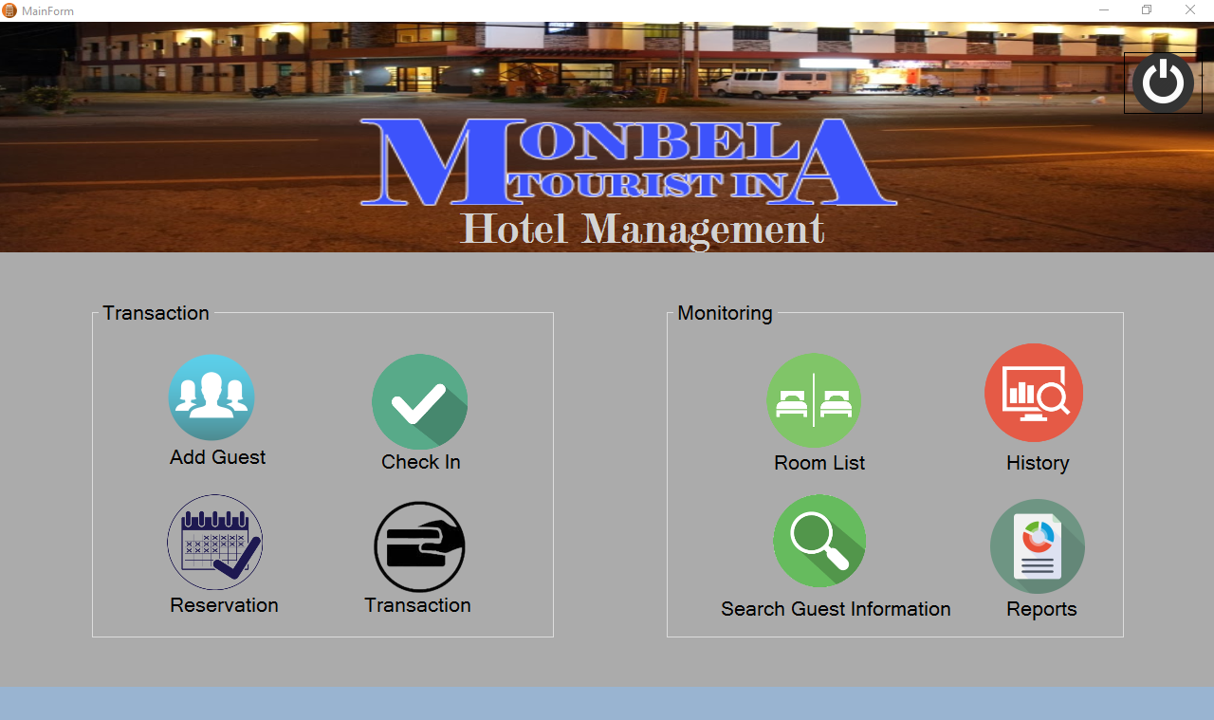

The above sample desktop system found in internet.

* The basic feature of this system is can easy access by an employee
* The main feature of this program is it can choose a room that suits the taste of a customer
* The rooms have three types of Single, Twice, Family and have an affordable cost
* of the rooms
* The system can add guest information
* Can see all of the total sales of the given day
* The admin can see all of the guest information
* The admin can cancel if the customer wants to cancel transaction

**b. Hotel management system**

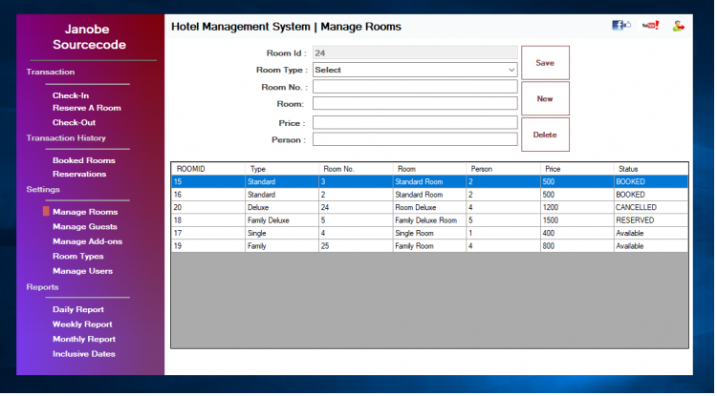

**This Hotel Management System** is also a software based that is made of Vb.net SQL database. Their main goal of the system is to also help to manage the operations and functions to gain greater stability and more profit as well.The following are the features of the system.

* Check-In
* Reservation
* Check-Out
* Bookings History
* Reservation History
* Manage Rooms
* Login and logout
* Allows guests to check-in and chooses room that is available
* It also has a billing function that can be issued receipts to the guests after they do the payment
* This is a user-friendly system
* Record the reservations of their guest to easily check in them

**c. Fronted Hotel management system**

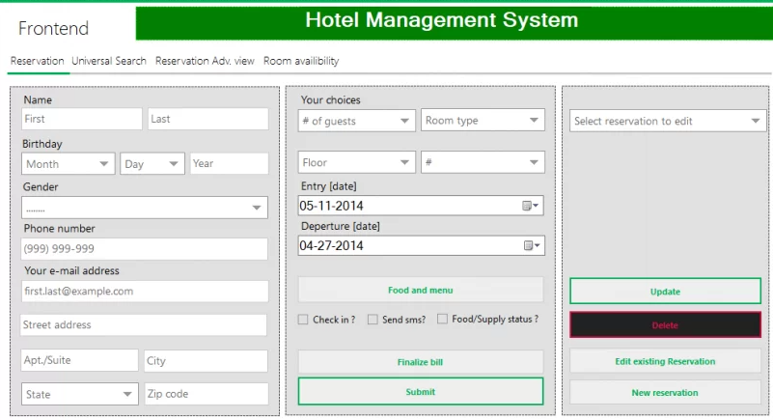

The above sample system is a frontend for hotel management system.

The following are the features of the system.

* Login reservation
* Add/edit/update/delete an entry
* Room Availability & Reservation
* Credit card & debit card verification
* SMS Service to send Receipts to Client
* Orders in Queue with complete details
* Overview of all orders from all hotel
* Record the reservations of their guest
* Universal Search field where you can search using any data type

## Table of Comparison with Other System

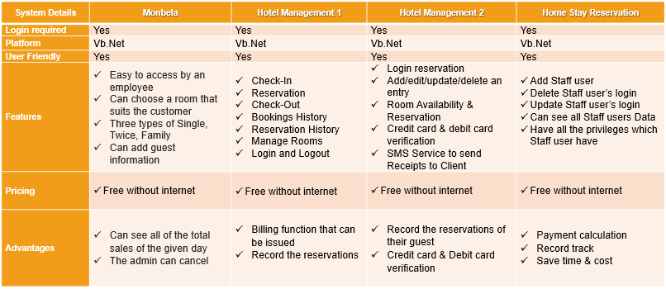

All the above three variety type of system but build in same software and for same reservation although not all for homestay but the method of reservation will serve the same. Other extra features available for billing and credit card verification.

# System DESIGN

## System Methodology

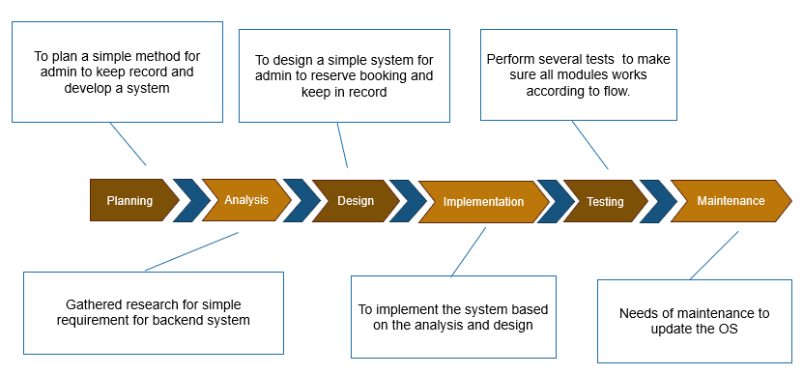

* + 1. **Software Development Process**

Different methodologies exist which is used in the development of the software process. These technologies are enlisted below

* Waterfall model
* Waterfall iterative model
* V model
* Spiral model
* Prototype model

**Waterfall Model**

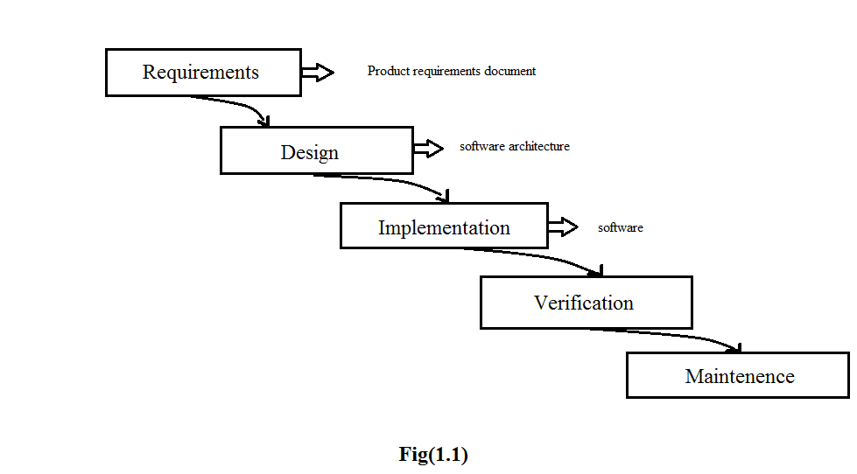

**5 phases of waterfall Model**

* + - 1. **Requirement Analysis and Definition**

All possible requirements of the system to be developed are started in this phase. Requirements are a set of function and constraints that the end user expects from the system.

* + - 1. **System and software Design**

The requirement specifications from the first phase are started here and a system design is preparing. Before starting the actual coding phase, it is highly important to understand the requirements of the end user and also have the idea of how the end product should look like.

* + - 1. **Implementation and Unit testing**

On receiving system design documents, the work is divided in modules and actual coding starts. The system is first elaborating into small programs called units, which are integrated in the next phase. Each unit is developed and tested or its functionality; this is referred to as unit testing.

* + - 1. **Integration and system testing**

The units are now integrated to form a complete system during the integration phase and tested to check if all the units are coordinating with each other, and the system as a whole behaves as per the specifications. After successfully testing the software, it is delivered to the customer.

* + - 1. **Operations and maintenance**

This phase of the model is virtually never-ending. Generally, problem with the system (which are note found during the development cycle) come up after its practical use starts, so the issues related to the system are solved after its development. Not all the problems come into picture directly, but they arise from time to time and need to be solved; hence this process is referred to as maintenance, even though it’s still pretty much in the testing phase.

## System Requirement

While my system functionality requirement as follows;

* Only admin have the permission to add staff user to use the system
* Manage Home Stay Bookings – Display Main Screen
* Make reservation - Customer/guest can reserve room or system maintenance- Staff user can reserve room for customer
* Delete reservation – staff can delete customer reservations
* Maintain Home/rooms

1. Add, update and delete homestay screen
2. Add, update and delete home stay room(s) screen

* Check In and Check out – Only receptionist user can check in and check out by validating customer.

## List of Facts and Assumptions

* **Experience**

1. The software developers should have a relative experience Regarding the Computer Science and collaborate with the owners so the developer take the ideas of what type of record management required. The customer must know that their information is recorded in their system. It is assumed that all the patients are familiar with tool and technology.

* **Skills**

1. Users should have basic knowledge and should be comfortable using general purpose application.
2. **Security**
3. Only authorized people will be able to access the system by entering the correct Login ID and password.

## Performance Requirements.

**a. Speed and latency requirements.**

System should response speedily as many customers book their rooms.

**b. Reliability and Availability requirements.**

System should provide very much reliability and it should not be halt in any case of burden and must be available all the time.

**c. Scalability or extensibility requirements.**

There can be a chance of enhancement so system should be scalable.

**d. Longevity requirements.**

Expected Lifetime of product according to the technologies used is 10 years.

## Software Quality attributes

The software be easily maintained and is upgraded so as to adapt to the ever-changing requirements of the company and provides additional features and functionalities. The software should be scalable. The software should be further easily upgradable so as to provide additional or new features by requiring minimum coding and adding specific or required design interface components. The software should be released with new features in different versions.

## What contribution would the project made?

It is an era of information Technology where automation of each activity is gaining importance. The app will lead to the organization and users to reserve reservations more and more effective way.

**3.6.1.** **Advantages**

* Allow easy personality test check at any time.
* Free of cost
* Not time consuming
* Increase efficiency
* Decrease labor hiring for keeping records

## Specific requirements

This section provides software requirements to a level of detail sufficient to enable designers to design the system and testers to test the system.

## Look and Feel Requirements

* + 1. **The interface**

The look of the interface is sober. The color scheme used in is simple and elegant as it is for any homestay. So, the color scheme is just as it suits to the system. All the items on the interface are visible and according to the standard colors, fonts and button etc.

* + 1. **The style Product**

We use professional approach for this and according to the standard colors, font and buttons etc.

* + 1. **Software Interface**

Any window-based operation system.

* + 1. **Hardware interface**

Screen resolution for at least 800x600 is required for proper and complete viewing of screen. Higher resolution will be accepted.

## Software Product Feature

* + 1. **Sequencing Information**

Data should be stored only in a particular sequence to avoid any inconvenience.

## Usability and Humanity Requirements.

* + 1. **Ease of use**

This system will be easy to use because its interface is easy and attractive.

* + 1. **Ease of learning**

We have already explained that the system will be friendly. We will also provide a user manual after its complete development

* + 1. **Understandability and politeness Requirements**

The interface and everything regarding to the interface will be easy to understand. For more help, its user manual is available.

* + 1. **Design constraints**

None.

* 1. **User characteristics**
* **Educational level:** User should be comfortable with the English language
* **Experience level:** User should have previous information regarding to the computer field.
* **Skills:** user should have basic knowledge and should be should be comfortable using general purpose applications on computer and on internet online systems.
  1. **Operational Requirements.**
     1. **Expected Physical Requirements**

Product will be used in home stay or hotels reservations.

* + 1. **Expected Technological environment**

Sql server, Visual Studio (Code)

* 1. **Maintainability and support Requirements.**
     1. **Maintenance Requirements:**

The system can be maintained in present or future. It will be easy to incorporate new requirements in the individual modules.

* + 1. **Adaptability Requirements:**

Any window-based operating system

Sql Server

* 1. **Legal Requirements**
* **Compliance Requirement**

The whole system does not violate any law or policy imposed by the Government.

* **Standard Requirements**

We will follow the standard or requirement of hotel and home stay reservation’s manual.

* **Other Requirements**

None.

* 1. **Data flow diagram**

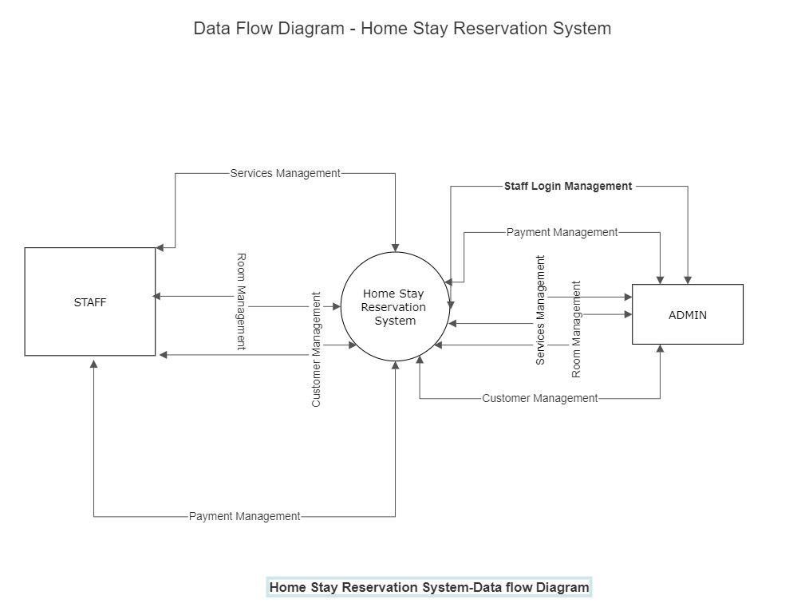

The above diagrams show data flow of the system.

* 1. **Use Case Diagram**

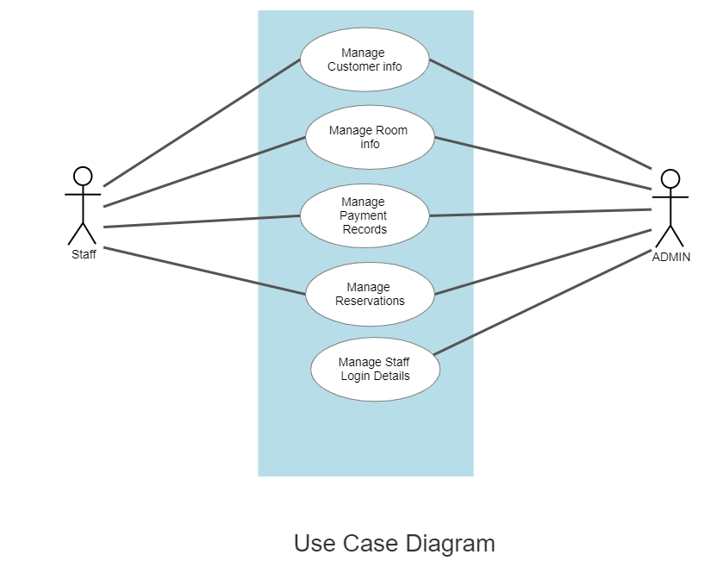

The above diagrams show the use case diagram

* 1. **Entity Relationship Diagram**

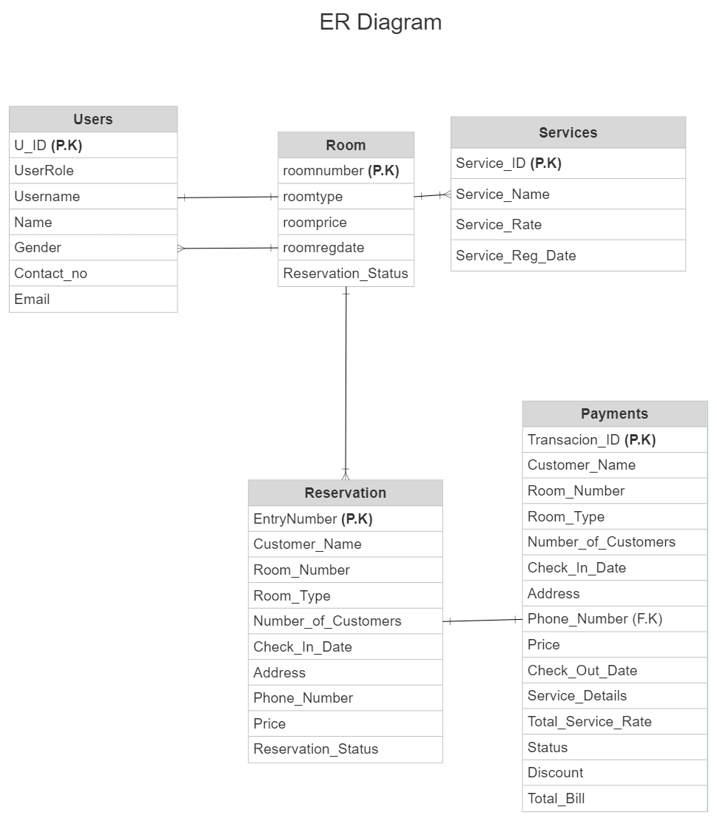

The above shows the Entity Relationship Diagram

The following are the required development Tools

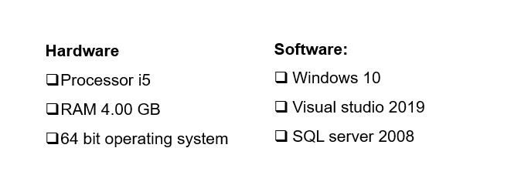

* 1. **Sample System Design – Features**

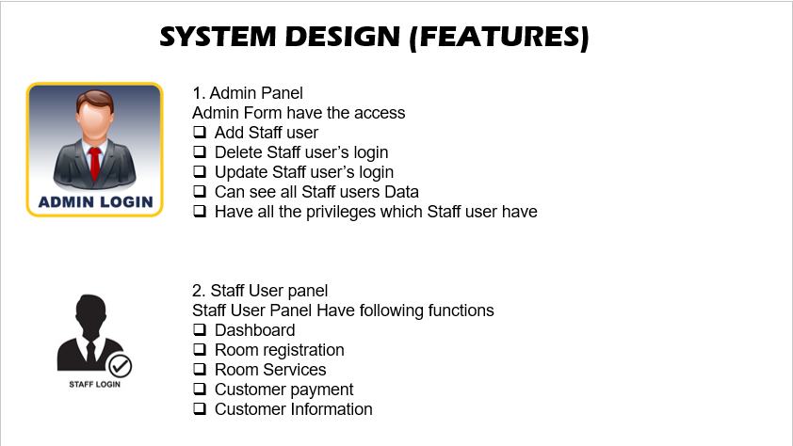

The above shows system design features for both admin panel and staff user panel.

The following are the extension points:

* Delete Reservation
* Make Reservation
* Update home stay info
* Delete home stay
* Delete room
* Update room

The below is the detailed features,

**1.Admin-Panel  
 Admin Form have the access**

* Add Staff user
* Delete Staff user’s login
* Update Staff user’s login
* Can see all Staff users Data
* Have all the privileges which staff user have

**2.Staff-User-panel**Staff User Panel Have following functions.

**2.1. Dashboard will show the total rooms.**

* Rooms which are reserved.
* There will be check in records of those who check in today.
* There will be a record of checkout guest.
* There is data gird which will have the list of available rooms
* There will be a list of customers which are in home stay

**2.2. Room registration**

* The rooms will be registered in this module.
* There will be a grid which show the data of available rooms. The employee will select the room from list according to customer requirements.
* check the status if the room is available or not
* There will be a search box which help to filter the customer information who reserved the room
  1. **Room service**
* There will be a form which is for registration of services. The services, which are used by guest will be add from available list. Or custom service will able to add if it is not registered.
  1. **Customer payment**
* In this form, customer data will be retrieved from database. The room charges and services charges will be added in this form.
* There will be function of discount (if any).
* Finally, the room price, service and discount will be added and total bill will be generated.
  1. **Customer information**
* It shows the information of all customers.
* It also will have the information of checkout/check in customers.
* There will be a filter for customer name search.
* There will be date filter to see the records.

# Deliverables and timeline

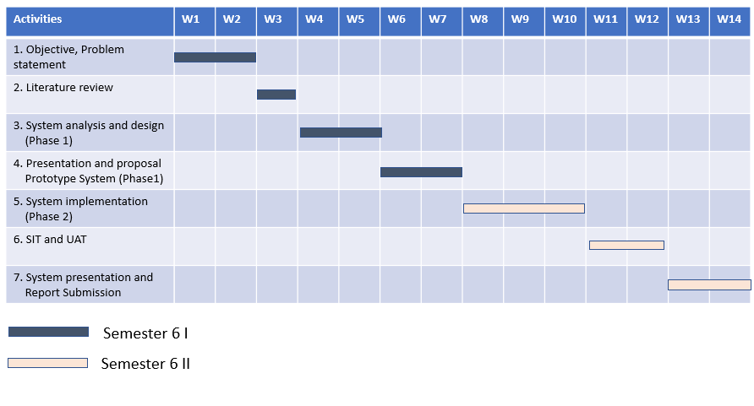

System development will take around 14 weeks. This is the total timeline include system requirement study until system go live.

# CONCLUSION

At the end, in this reservation management system it is a user-friendly for the backend admin / staff.

This system will save the time and cost, and will help to manage the record or reservation properly

This will also help in growth of the company and improve knowledge in technology wise without creating any hassle

References

Burton-Jones, A. and Grange, C. (2012), From use to eﬀective use: A representation theory perspective,Information Systems Research, published online before print November8, 2012

Buchwalow, I. B., and Böcker, W. (2010). Immunohistochemistry: basics and methods. Berlin: Springer Verlag.

Bradley, G. (2010),Beneﬁt Realisation Management: A Practical Guide to Achieving Beneﬁts through Change , Gower, Aldershot, UK.

Barclay, C. and Osei-Bryson, K. (2009), Toward a more practical approach to evaluating programs: The Multi-Objective Realization approach,Project Management Journal ,vol. 40, no. 4, pp. 74–93.

Caamaño-Tubío, R. I., Pérez, J., Ferreiro, S., and Aldegunde, M. (2007). Peripheral serotonin dynamics in the rainbow trout (Oncorhynchus mykiss). Comparative Biochemistry and Physiology Part C: Toxicology & Pharmacology, 145(2): 245-255

Bradley, G. (2006),Beneﬁt Realisation Management , Gower, Aldershot, UK.

Cakir, Y., and Strauch, S. M. (2005). Tricaine (MS-222) is a safe anesthetic compound compared to benzocaine and pentobaritol to induce anesthesia in leopard frogs (Rana pipiens). Pharmacological Reports, 57: 467-474.

Brynjolfsson, E. and Brown, P. (2005), Seven pillars of productivity,Optimize , vol. 4, no.5, pp. 26–35.

Brady, T. and Davies, A. (2004), Building project capabilities: From exploratory to exploit-ative learning,Organization Studies , vol. 25, no. 9, pp. 1601–1621.

Cameron, A. A., Plenderleith, M. B. and Snow, P. J. (1990). Organization of the spinal cord in four species of elasmobranch fishes: cytoarchitecture and distribution of serotonin and selected neuropeptides. The Journal of Comparative Neurology, 297: 201-218

Appendix

(Please delete this part): Appendices consist of additional illustration of data sources, raw data and quoted citations which are too long to be placed in the text. The appendix supports the written text of the research report/dissertation/thesis. Research instruments such as questionnaires, maps or computer programmers are parts of appendix too.

Appendices can be divided into Appendix A, B, C.

This page is optional; if you do not have any appendices, delete the entire page.